**RC Circuits**

QS 1. The switch in the circuit given below has been in position ‘a’ for a long time. At 𝑡=0, the switch is moved to position ‘b’. Find 𝑖𝑜(𝑡) for 𝑡≥0+.



Solution



Qs 2

The switch in the circuit given below was close for a long time and it is opened at 𝑡=0. Find voltage across capacitor for 𝑡≥0.



Solution



Qs 3

The switch in the circuit given below has been in position ‘a’ for a long time. At 𝑡=0, the switch is moved to position ‘b’. Find 𝑉𝑐(𝑡) for 𝑡≥0.



Solution



Qs 4

The switch in the circuit given below has been in position ‘a’ for a long time. At 𝑡=0, the switch is moved to position ‘b’. Find 𝑉𝑐(𝑡) for 𝑡≥0.



Solution



Qs 5

The switch in the circuit given below has been in position ‘a’ for a long time. At 𝑡=0, the switch is moved to position ‘b’.

a) Find 𝑉𝑜(𝑡) for 𝑡≥0

b) Find 𝑖𝑜(𝑡) for 𝑡≥0+



Solution



Qs 6

The switch in the circuit given below was close for a long time and it is opened at 𝑡=0. Find 𝑉𝑐(𝑡) for 𝑡≥0.



Solution



QS 7

Find equivalent capacitance with respect to terminals A and B.



Solution



Qs 8

Find equivalent capacitance with respect to terminals ‘a’ and ‘b’.



Solution



Equailent Capacitance

**QS**



**Solution**



Qs 9

The switch in the circuit given below has been in position ‘a’ for a long time. At 𝑡=0, the switch is moved to position ‘b’. Find 𝑉𝑐(𝑡) for 𝑡≥0



Solution



Qs 10

The switch in the circuit given below was close for a long time and it is opened at 𝑡=0. Find 𝑉𝑜(𝑡) for 𝑡≥0.



Solution



**Qs 11**

Find voltage and energy of capacitor



Solution

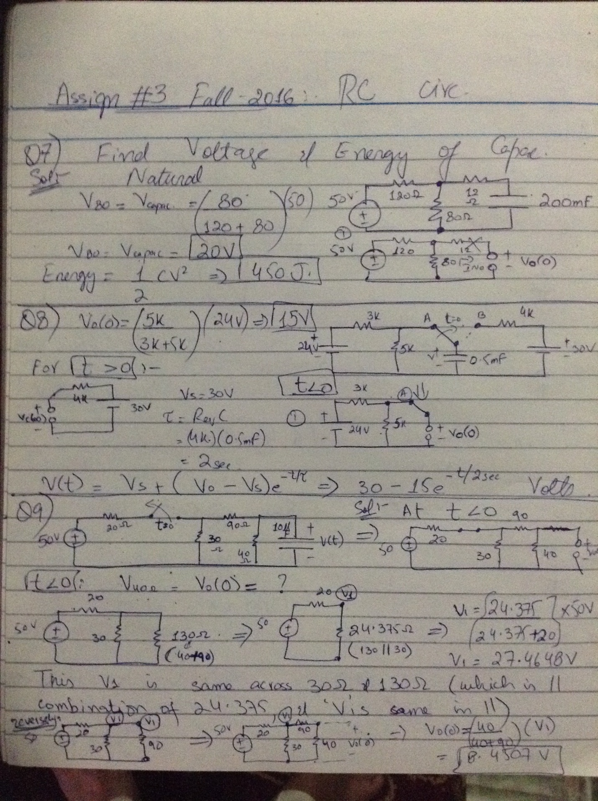

Qs 12

Find the response ‘v(t)’ of capacitor



Solution

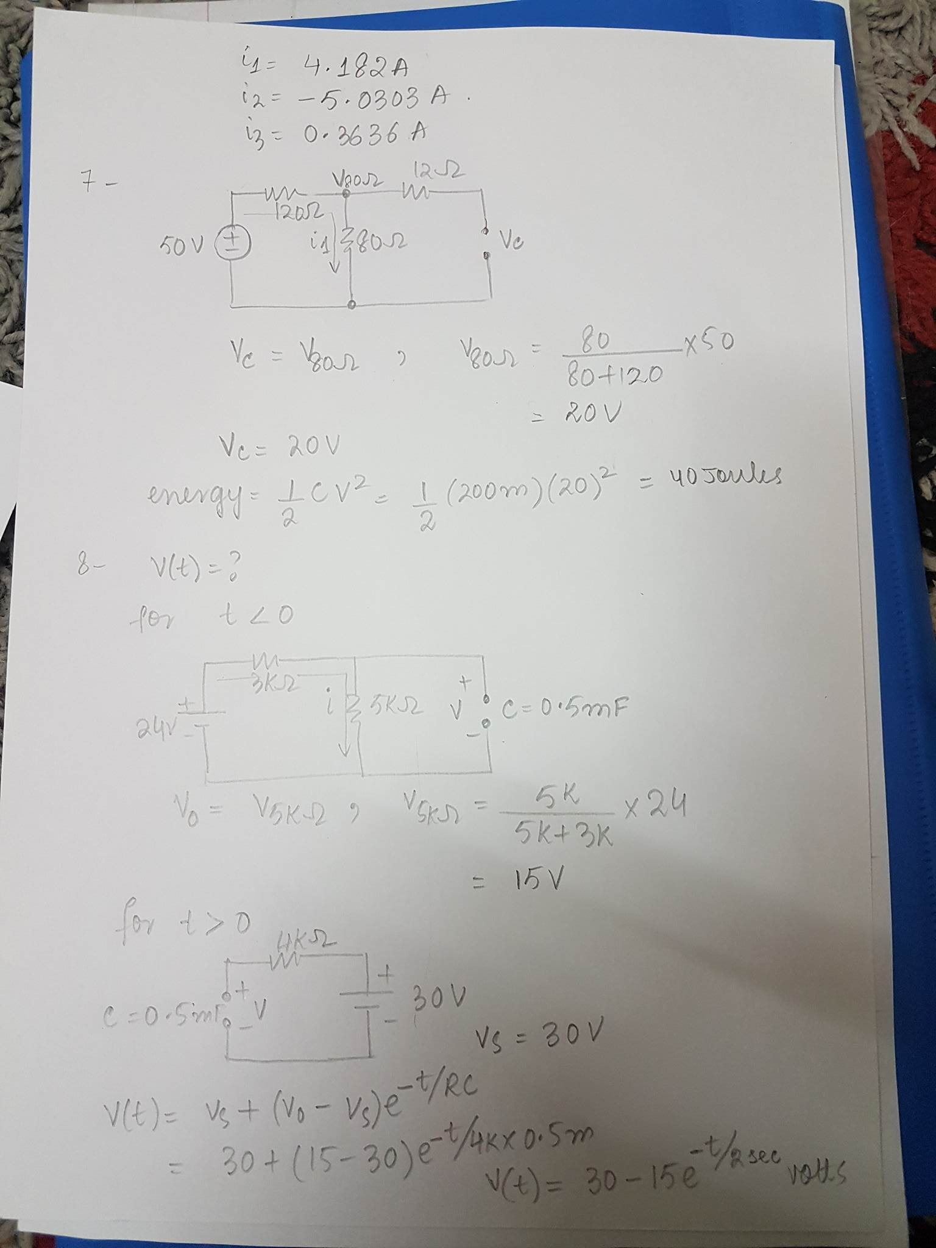

Qs13

The switch in the below circuit has been closed for a long time and is opened at t=0. Find the response ‘v(t)’ of the capacitor



Solution

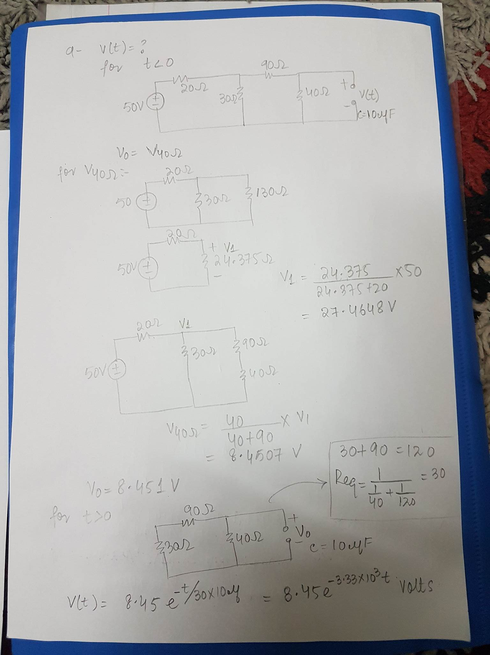

QS 14

The switch in the below circuit has been closed for a long time and is opened at t=0. Find the response ‘v(t)’ and current ‘i(t)’ in the following circuit



Solution

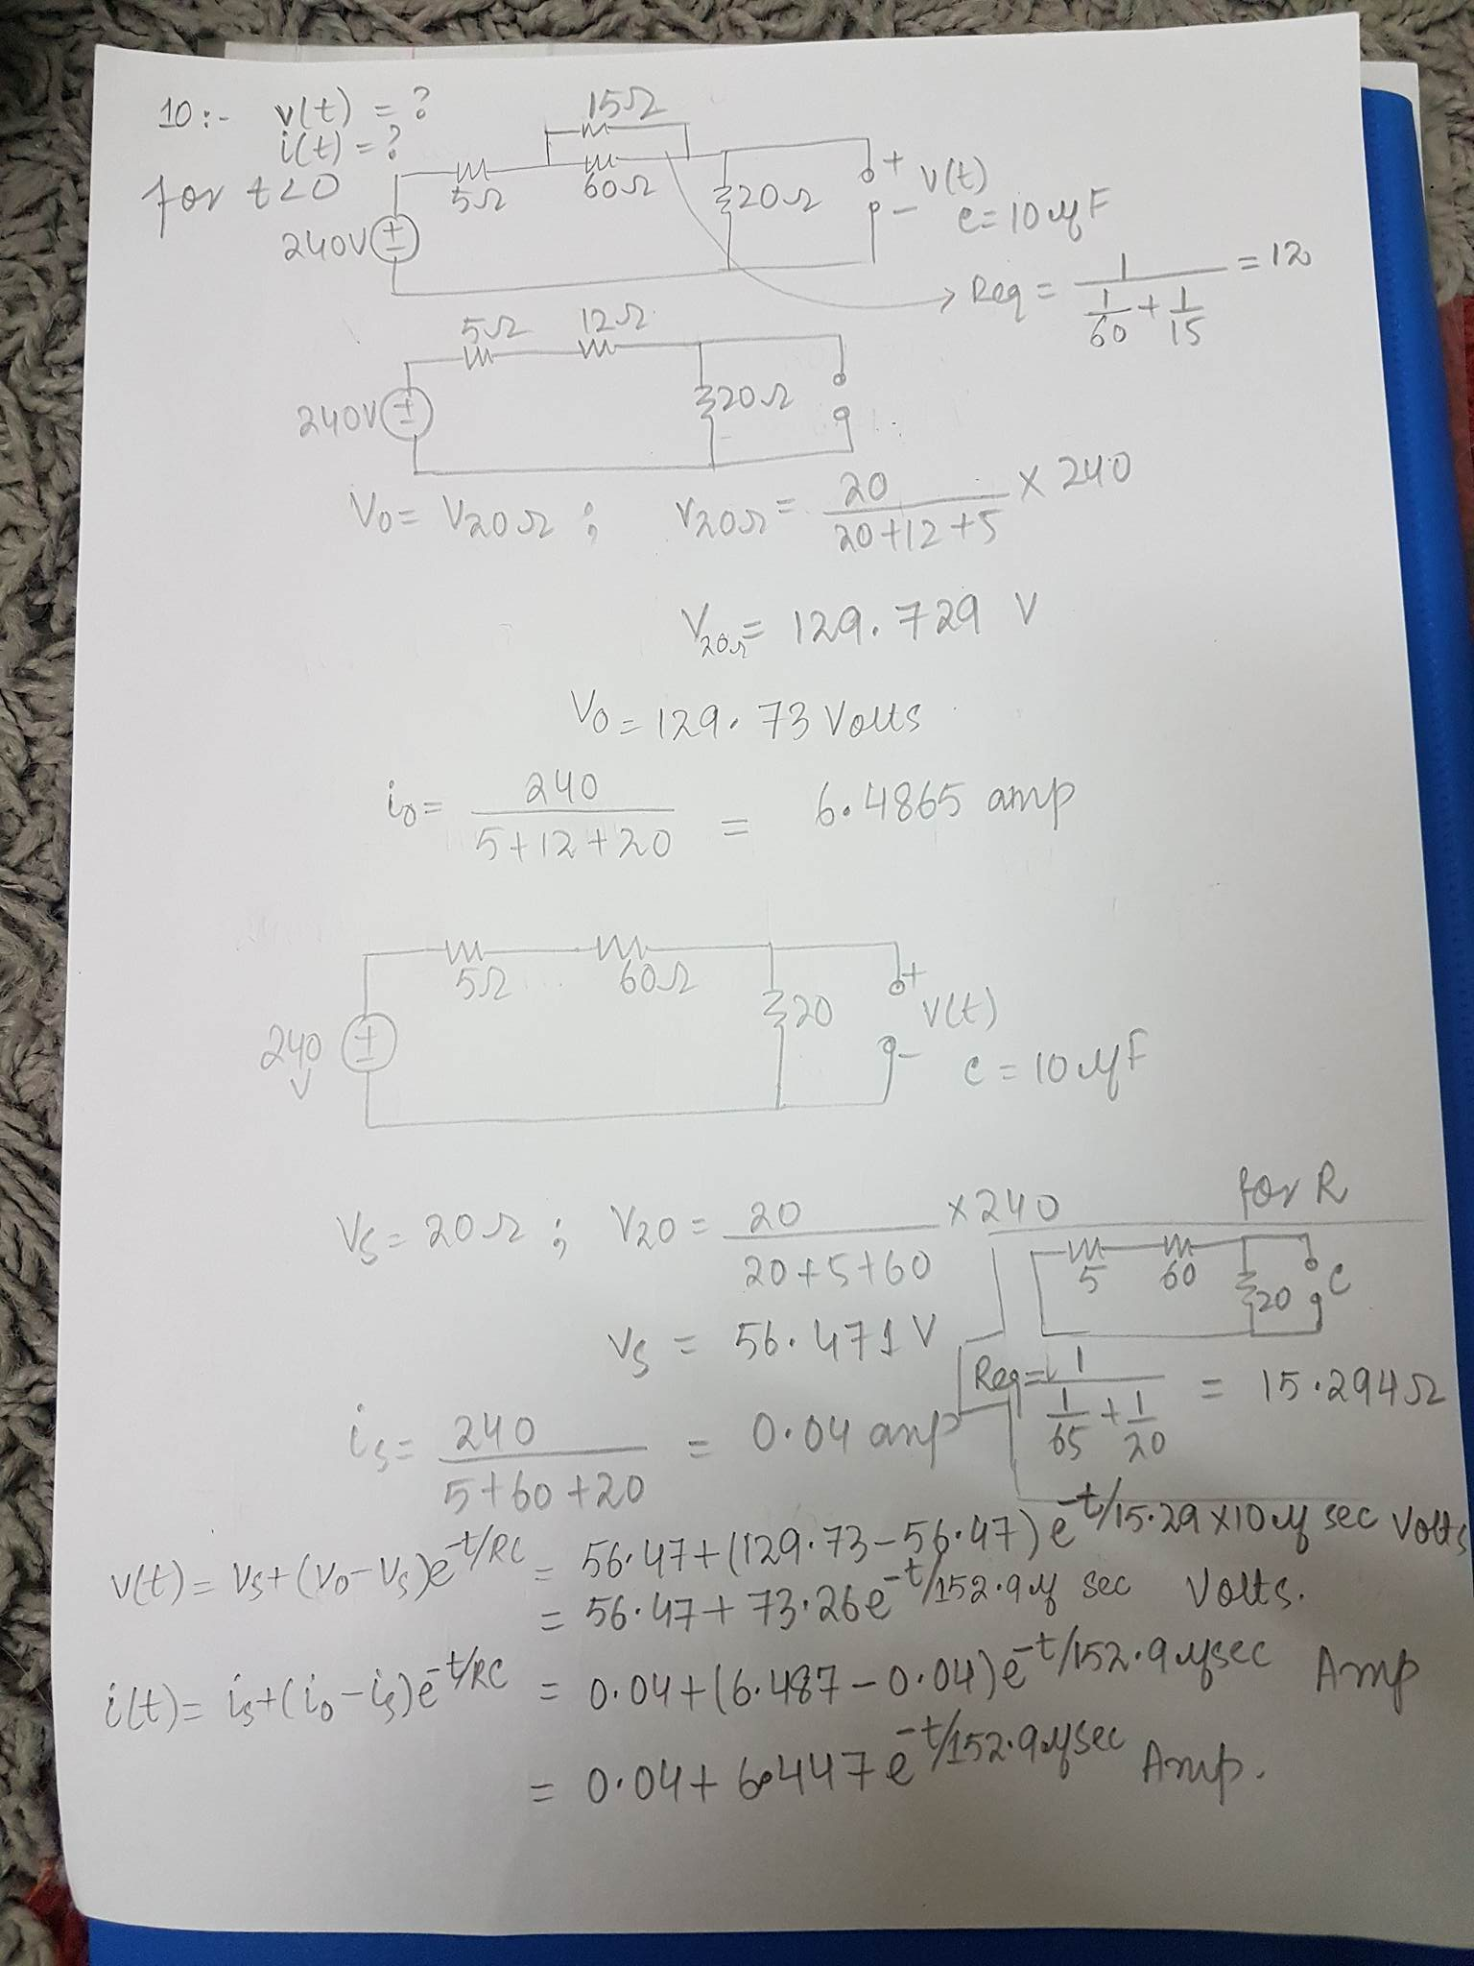

Qs15

The switch in the below circuit has been closed for a long time and is opened at t=0. Find:

a) The initial value of V(t)

b) The time constant for t ˃ 0

c) The numerical expression for V(t) after the switch has been opened



**Solution**

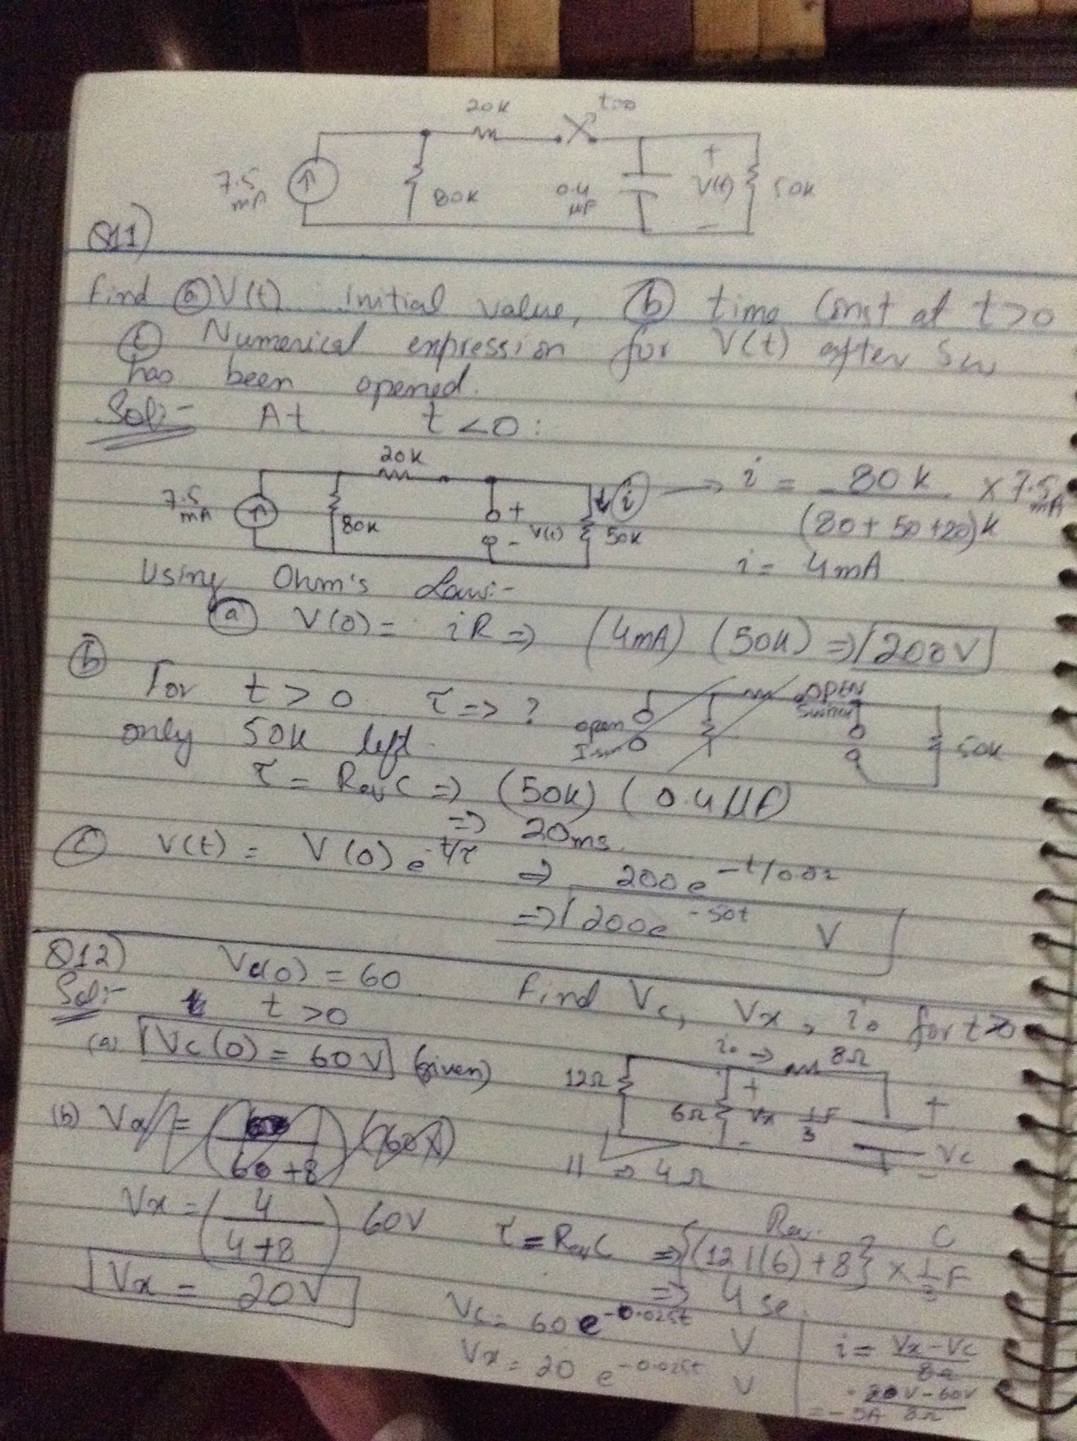

Qs16

Let Vc(0) = 60V. Determine Vc, Vx and io for t ˃ 0.



Solution



Qs 17

The switch in the circuit has been closed for a long, and it is opened at t = 0. Find V(t) for t ˃ 0. Calculate the initial energy stored in the capacitor.



Solution

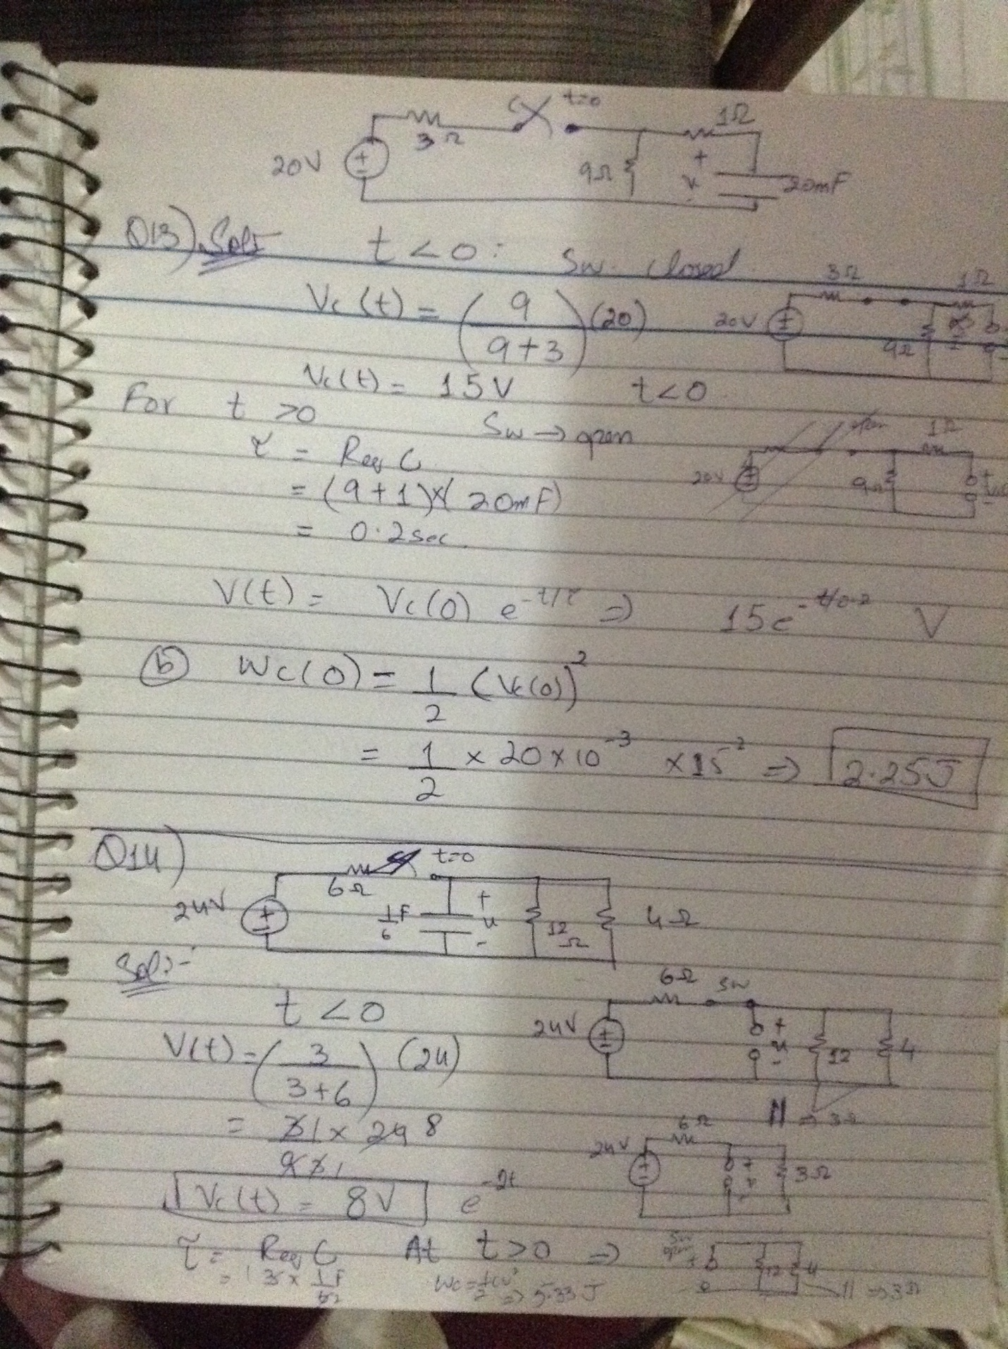

Qs 18

If the switch in the below circuit open at t = 0, find V(t) for t ˃ 0 and also initial energy stored in the capacitor.



Solution



Qs 19



Solution

